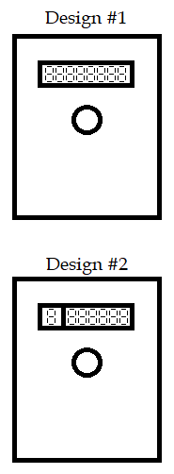

**Design #1:**

* Simple to make
* Both left & right turning
* Possible numbers [0, 9]
* Easy to enter

**Design #2**

* Only one number visible at a time
* Left & Right turning
* Possible numbers: depends on number of displays
* Might be tedious to enter with larger numbers.

(large amount of turning)

**Common to both designs:**

* Reset button to reprogram code on inside
* Multiple quick presses for actions such as cancelling input
* Use 74595 for something like counting the amount of attempts made to open the lock, or something… (I don’t see a place where we really *need* it.
* If we can use the ESP32:
  + Connection to vault using an app
  + App can:
    - Open the vault w/ passcode
    - Change the passcode (only when vault is OPEN)
    - Connect vault to internet (enter password etc)
    - Receive notifications from vault about suspicious attempts to open the vault, etc.

